Internship Report
Of
Data Science

Submitted
To
School of Computer Science and Engineering
IILM University, Greater Noida, U.P.

In partial fulfilment of the requirement of degree of
B.Tech CSE



By
Roll Number of Student:25SCS1003000793
Name of Student: NITIN KARKI
Batch: 2025-2029

2026-27

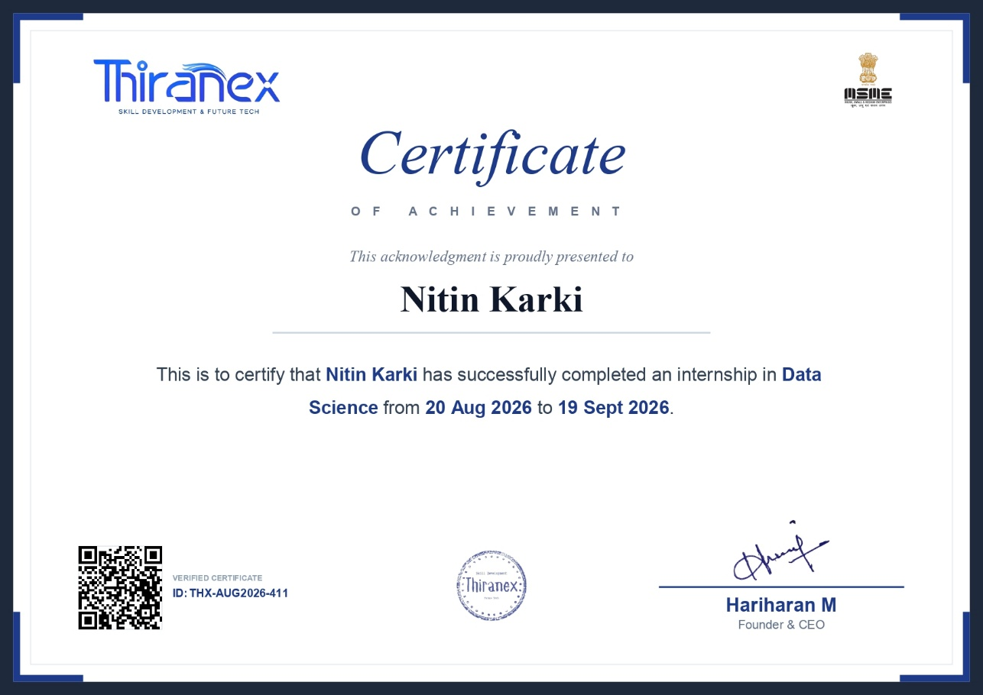

CANDIDATE’S DECLARATION

I, NITIN KARKI do hereby declare that the internship report titled “Data Science” has been completed by me to fulfil the requirement for the award of the degree of Bachelor of Technology in CSE. All the references have been quoted and I have not taken as such any material from any other source. I affirm to you that this report is my own and has not been submitted to any other institute for any degree/diploma requirement and further I shall be solely responsible for any kind of copyright violation in this regard.

Signature
Student Name: NITIN KARKI
Roll No.: 25SCS1003000793

ACKNOWLEDGEMENT

I am using this opportunity to express my gratitude to everyone who supported me throughout the Internship Program. I am thankful for their aspiring guidance, invaluably constructive criticism and friendly advice during this work. I am sincerely grateful to them for sharing their truthful and illuminating views on a number of issues related to this work.
I express my gratitude to my parents for their blessings.

Signature
Student Name: NITIN KARKI
Roll No.:25SCS1003000793

1.Introduction
1.1 Background
As part of the curriculum for the Bachelor of Technology programme in Computer Science & Engineering (AIML) at IILM University, Greater Noida, students are required to undertake an industry internship to gain practical, hands-on exposure to real-world applications of the concepts studied in the classroom. This report documents the internship undertaken in the field of Data Science at Thiranex – Skill Development & Future Tech.
1.2 About the Internship
The internship focused on core Data Science skills, including data cleaning, exploratory data analysis, visualization, and predictive modeling using machine learning. It was conducted over a period of one month, from 20 August 2026 to 19 September 2026, and consisted of four structured, task-based projects designed to build practical competency progressively – from data preprocessing to end-to-end applied analysis.

2. Objectives of the Internship
The key objectives set out for this internship were as follows:
- To gain practical experience in cleaning, processing, and visualizing raw datasets.
- To learn and apply supervised machine learning algorithms for predictive modeling.
- To develop skills in exploratory data analysis (EDA) and statistical interpretation of data.
- To apply the above data science skills end-to-end on a domain-specific, real-world dataset.
- To develop analytical thinking, data storytelling, and structured technical reporting skills.

3. Training Undergone
3.1 Duration and Mode
The internship was undertaken in remote/online mode over a duration of one month, from 20 August 2026 to 19 September 2026, under Thiranex’s Skill Development & Future Tech programme. The training followed a task-based structure, with each task accompanied by a tutorial, a defined set of key features to implement, and an expected learning outcome.
3.2 Summary of Tasks Undertaken
The four tasks completed during the internship are summarized in Table 4.1 and described in detail in Chapter 4.
S.No. | Task / Project | Status
1 | Data Cleaning & Visualization Project | Completed
2 | Predictive Modeling Using Machine Learning | Completed
3 | Exploratory Data Analysis (EDA) Project | Completed
4 | Domain-Specific Applied Dataset Project | Completed

Table 4.1: Summary of Internship Tasks / Projects

4. Project Description
4.1 Introduction
This chapter describes, in detail, the four projects undertaken during the Data Science internship at Thiranex. Each project was designed to build a specific set of practical skills, beginning with foundational data handling and progressing towards an independently executed, domain-specific applied project.
4.2 Organization Profile
Thiranex is a skill development and future-technology-focused organization that offers structured, industry-oriented internship programmes in emerging technology domains such as Data Science, Machine Learning, and related fields. The organization’s internships are designed around practical, task-based learning modules, supported by video tutorials and clearly defined deliverables, enabling interns to build job-ready technical skills. The internship completion certificate (Certificate ID: THX-AUG2026-411) was issued and verified by the organization on completion of the programme.
4.3 Problem Statement
Organizations today generate large volumes of raw, unstructured data that must be cleaned, analyzed, and modeled before it can support meaningful, data-driven decisions. The problem addressed through this internship was to gain hands-on competence in the complete data science workflow – from raw data ingestion and cleaning, through exploratory analysis, to predictive modeling – and to apply this workflow independently to a real, domain-specific dataset.
4.4 Project Objectives
The specific objectives of the four projects undertaken were:
- Data Cleaning & Visualization: To handle missing values, outliers, and duplicates in a raw dataset, and to visualize the cleaned data to generate insights.
- Predictive Modeling Using Machine Learning: To build, train, and evaluate a machine learning model capable of predicting outcomes from a given dataset.
- Exploratory Data Analysis (EDA): To analyze a dataset using statistical summaries and visualizations to uncover underlying patterns and trends.
- Domain-Specific Applied Project: To apply the complete data science workflow end-to-end on a domain-specific dataset of choice.
4.5 Scope of the Project
The scope of the internship was limited to the application of standard, open-source data science tools on publicly available or provided datasets, within a structured, task-based training environment. It covered data preprocessing, statistical and visual exploratory analysis, and supervised machine learning model development and evaluation, culminating in an independently chosen domain-specific applied project.
4.6 Technologies and Tools Used
- Programming Language: Python
- Libraries: Pandas and NumPy (data handling), Matplotlib and Seaborn (visualization), Scikit-learn (machine learning)
- Machine Learning Algorithms: Linear Regression, Decision Trees, Random Forest
- Evaluation Techniques: Train–test split, confusion matrix, ROC curve analysis
- Environment: Jupyter Notebook
4.7 System Architecture
The overall workflow followed across the four projects can be represented as a standard data science pipeline: Raw Data Collection → Data Cleaning & Preprocessing (handling missing values, outliers, and duplicates) → Exploratory Data Analysis (statistical summaries and visualizations) → Feature Preparation → Model Building & Training (Linear Regression / Decision Tree / Random Forest) → Model Evaluation (accuracy, confusion matrix, ROC curve) → Presentation of Insights (dashboards, visual reports, and structured findings).
4.8 Methodology
Task 1 – Data Cleaning & Visualization: A raw dataset was processed to handle missing values, outliers, and duplicate records using Pandas. Cleaned data was then visualized using Matplotlib and Seaborn to build dashboards and visual reports highlighting key findings.
Task 2 – Predictive Modeling Using Machine Learning: A dataset was split into training and testing sets, and supervised learning algorithms – Linear Regression, Decision Trees, and Random Forest – were applied to predict target outcomes. Model performance was evaluated and visualized using confusion matrices and ROC curves.
Task 3 – Exploratory Data Analysis: A dataset was analyzed using statistical summaries (mean, median, distribution, correlation) alongside visualizations to identify patterns, trends, and key influencing factors. Findings were consolidated into a structured report.
Task 4 – Domain-Specific Applied Project: A domain-specific dataset was selected for applied, end-to-end analysis, combining the preprocessing, exploratory analysis, and predictive modeling techniques learned in Tasks 1–3, with findings presented through visualizations and conclusions.
4.9 Expected Outcomes
- Proficiency in data preprocessing, cleaning, and visualization using Python.
- Practical experience in supervised machine learning and model evaluation.
- Strengthened analytical thinking and data exploration skills.
- Ability to apply data science techniques independently to real-world, domain-specific problems.
- Improved skills in data storytelling and structured technical reporting.
4.10 Certificate of Completion
The internship was completed successfully, and a verified certificate of completion (Certificate ID: THX-AUG2026-411) was issued by Thiranex for the Data Science internship undertaken from 20 August 2026 to 19 September 2026. A copy of the certificate is attached at the beginning of this report.

5. Bibliography / References
1. McKinney, W. (2017). Python for Data Analysis (2nd ed.). O’Reilly Media.
2. Pandas Development Team. Pandas Documentation. Retrieved from https://pandas.pydata.org/docs/
3. Scikit-learn Developers. Scikit-learn Documentation. Retrieved from https://scikit-learn.org/stable/
4. Waskom, M. (2021). Seaborn: Statistical Data Visualization. Journal of Open Source Software.
5. Thiranex – Skill Development & Future Tech, Internship Task Portal (2026).

